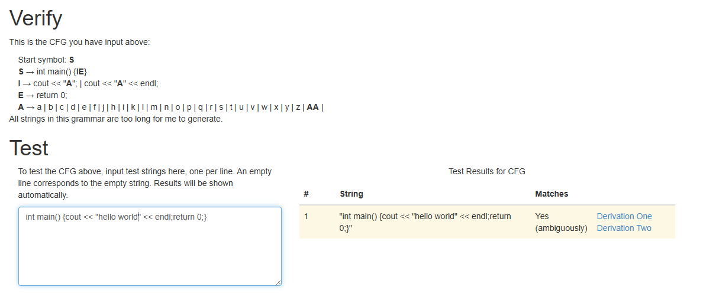

S → int main() {IE}

I → cout << "A"; | cout << "A" << endl;

E → return 0;

A → a | b | c | d | e | f | j | h | i | k | l | m | n | o | p | q | r | s | t | u | v | w | x | y | z | AA |

https://web.stanford.edu/class/archive/cs/cs103/cs103.1156/tools/cfg/